Supplementary results
We present results here for three additional datasets: the infant birth weight data (Bwt), the breast cancer data (Breast) and the lung prognosis data (Lung). These demonstrate that our findings are not data-dependent. Data characteristics are presented in Supplementary Table 1.
We found that both, the statistical synthetic data generation and the CTGAN approach are able to generate synthetic datasets with similar mean values but they differ in their skewness and kurtosis. Not all but most variables in all three datasets have similar variances compared with the corresponding values in the real data. As for the distribution, Supplementary Figure 7 visualizes the two-dimensional density of two variables in the Lung data, this is representative for other variable pairs. Both the statistical and CTGAN synthetic datasets (Supplementary Figure 7, second and third columns, respectively) resemble the real data (Supplementary Figure 7, first column), indicating that both methods can represent correlated covariates of different types.
In terms of practical considerations, Supplementary Table 2 presents downstream analysis results for these additional three datasets. The statistical approach and the CTGAN approach achieve comparable performances among all three datasets with the statistical approach being slightly better. For instance, the balanced accuracy in the Breast data using the statistical approach generated synthetic datasets is 0.94 (0.01), whereas a lower value of 0.87 with a larger variability (0.27) is found using the CTGAN approach.

Supplementary Table 1. Extra datasets.
Datasets | Bwt | Breast | Lung
Number of observations | 189 | 569 | 168
Number of variables | 4 | 30 | 7
Outcome variables | Continuous | Binary | Censored survival
Number of continuous covariates | 2 | 30 | 5
Number of binary covariates | 1 | 0 | 1
Number of categorical covariates (binary and ordinary) | 2 | 0 | 2
References | Venables WN, Ripley BD (2002). Modern Applied Statistics with S, Fourth edition. Springer, New York. ISBN 0-387-95457-0, Available at https://www.rdocumentation.org/packages/MASS/versions/7.3-61/topics/birthwt. | Street, W.N., Wolberg, W.H., & Mangasarian, O.L. (1993), “Nuclear feature extraction for breast tumor diagnosis,” Biomedical image processing and biomedical visualization, 1905, 861-870. | Loprinzi CL., Laurie JA., Wieand HS., Krook JE., Novotny PJ., Kugler JW., Bartel J., Law M., Bateman M., & Klatt NE. et al. (1994), “Prospective evaluation of prognostic variables from patient-completed questionnaires,” Journal of Clinical Oncology, 12(3):601-7.

Supplementary Table 2. Prediction performances.
Dataset | Prediction model | Metric | Statistical approach (mean & sd) | CTGAN (mean & sd)
Bwt | Linear regression | MSE | 460997.57 (0.07) | 552569.86 (73011.59)
Breast | Logistic regression | Balanced accuracy | 0.94 (0.01) | 0.87 (0.27)
Lung | Cox model | C-index | 0.64 (0.01) | 0.64 (0.01)

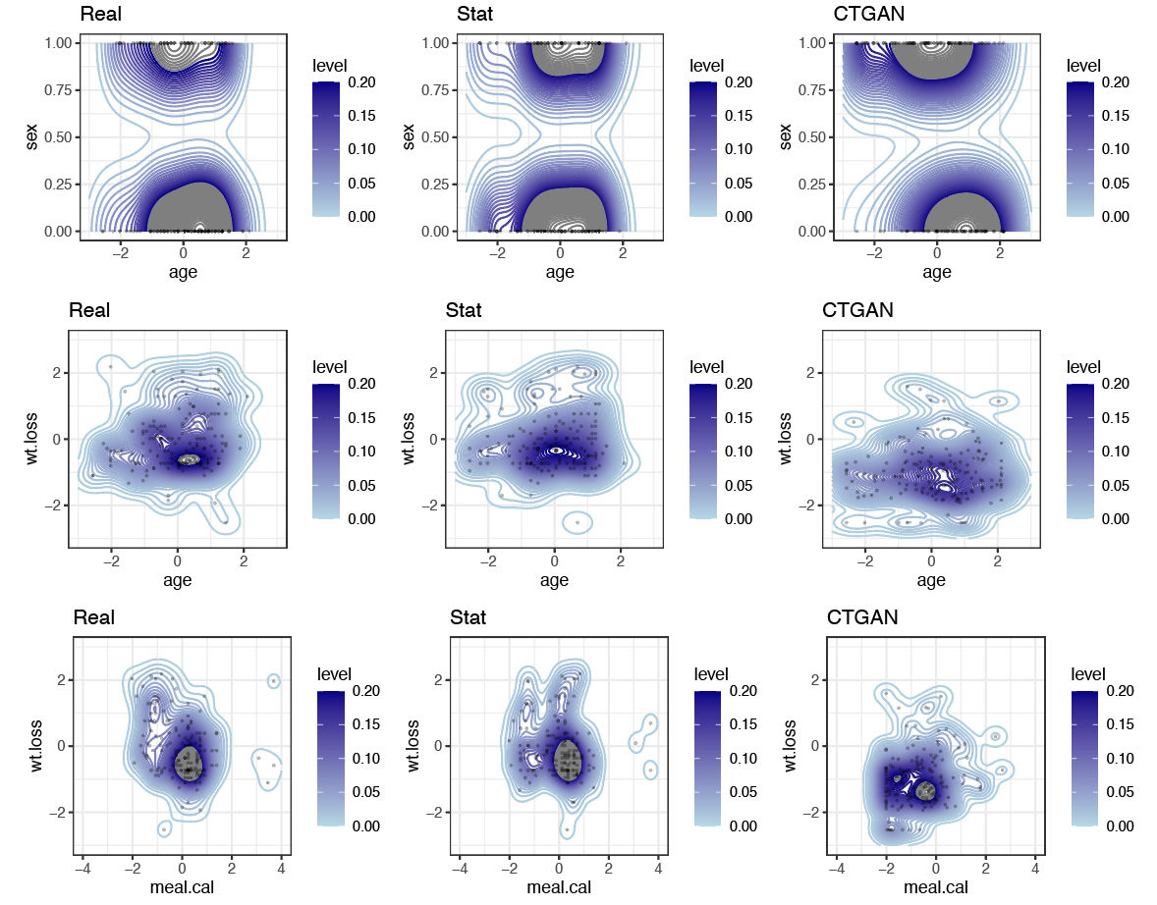
Supplementary Figure 7. Two-by-two density level plots among variables for the Lung dataset. The first row shows densities between one continuous variable and one categorical variable. The second and the last row show densities among two continuous variables. The first column shows the real data, whereas the second and third columns show one of the 100 generated synthetic data using the statistical and the CTGAN approach, respectively.

